Lumecca Case Studies

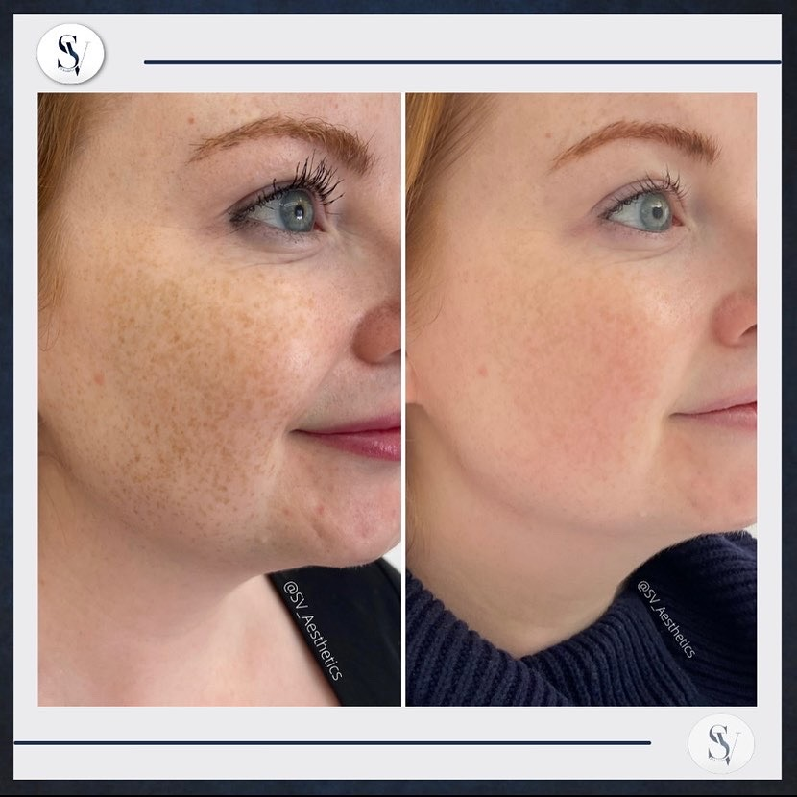

Physician: SV Aesthetics

Procedure: Lumecca IPL 515nm

Number of Sessions: Before & After 2 Sessions on Full Face

Age: Female, 35

Area Treated: Full Face

Energy: 12 J/cm2

Cooling: Strong

Description/More Details:

Female with skin type 1 requested treatment to reduce freckles on full face. These are the results after 2 sessions. On each session we did one pass on the entire face & a 2nd lower pass after 15 minutes on a 20% reduced settings – we avoided the forehead on the 2nd pass. Pigments darkened after each session & then became lighter.